My sincere apology for the late response as I have been spending too much time on my new born. I thank much the efforts of the authors in revising the manuscript. While my view will probably not affect the editor’s/recommender’s decision I feel that further comments may be helpful for improving the study, so I hereby provide two more.
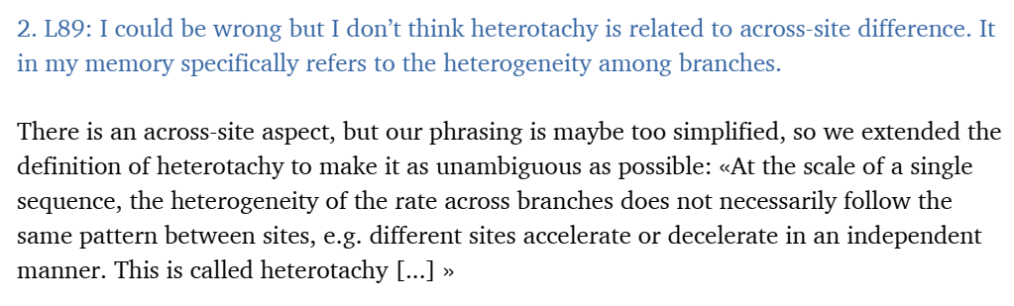This is incorrect. As I suggested before, heterotachy is not about across-site difference. It would be good to look at the wiki where it’s indicated in the first sentence “Heterotachy refers to variations in lineage-specific evolutionary rates over time”, and the cited literature there.

Also, the authors have carefully revised the ms regarding the weakness of using single genes in dating. I however still encourage the authors to strengthen and to expand related discussion a bit more, which would make the results and conclusion more stringent, in my view. Places where such discussion might be about could be “To start with, calibrating only one node is insufficient, but this is precisely the purpose of our analysis, since we study gene trees for which nodes lack calibrations”. Certainly, it’s the authors’ liberty to take it or not.

